The Casino: Family or Foe?
Of all adult Americans in the country, 60 percent gamble at least once yearly. This can partially be attributed to advertisements for casinos, which are ever-present in today’s society, inhabiting billboards in almost every city. However, appealing to the everyday gambler seems to be setting sights too low. This advertisement takes a unique approach by appealing to the audience’s emotions and attempting to present itself as credible, rather than risking using logic to draw these people into the casino.
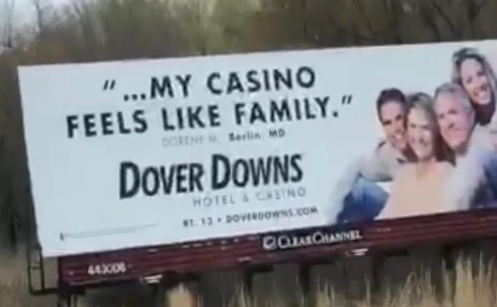
The voice speaking in this ad is a person who is supposedly addicted to gambling. They are so far in the rabbit hole as to say that “the casino is like family to me.” This is an utterly ridiculous claim and cannot be considered credible. Someone who has either found some sort of enjoyment in losing money for some reason or possibly made a massive amount of money in a short time would say this. However, it can be doubted that this is the only viewpoint on the situation (and it is probably not the most popular viewpoint either). The person saying this quote might not even be real; the advertiser could have merely put the “quote” up there to lure them in with the propaganda they are pushing out. This says that the creator of this ad is immoral in every way, shape, or form. They are in this to obtain money, and that is their only goal; this also says that they do not care about deceiving people or what consequences might ensue for the person who falls for this ad as long as they achieve their goal.
This advertisement is highly irrational. Comparing a family to a casino is a far leap, especially considering that any normal family would not take a person’s entire life savings right out of their hands with little to no reward. The billboard says this lie to lure adults in who could potentially have emotional issues within their families. It could also be appealing to some who love talking with others and finding new communities. By saying that the casino is like a family itself, it could attract those into the toxic environment of a casino while they think it could possibly be a second family to them during the times that they are facing. It could also lure them in if they simply want to have someone to talk to who feels like family. The other side of the coin that they could be appealing to is, of course, the average gambling addict. By making the environment seem a lot healthier than it is, the avid gamblers wander in and, like everyone else, spin the slot machines to likely no avail.
The main promise of the billboard is to find a family environment. However, it does not actually fulfill its promise. Casinos are not designed to be a family-like environment; they are instead designed to make money. Slot machines are set to not give out a substantial amount of money until the machine has made a certain amount of money. This means that all the adults who wander into the casino under their guise are dooming themselves to possible bankruptcy if they decide to spend more money than they originally planned. To further this, it may alienate them from the rest of their actual family, so this could completely backfire and cause them to lose what they sought to gain in the first place. Friends will probably end up leaving them behind too, and the gamblers at the casino may not be healthy replacements for those either. However, these negative outcomes are not discussed on the billboard and are concealed from the consumer behind the guise of being a positive and family-like environment. The creators execute this “wolf in sheep’s clothing,” so to speak, to turn an extremely negative environment into a positive one for their own monetary gain. It ends up being a blatant lie for them and instead of gaining a family, they have gained an addiction.
The billboard has imagery to try to be inclusive as well. It displays four people, each wearing an over-the-top amiable smile and close to each other as if they were posing for a picture. Both males and females are present in the image. They vary in age, some looking younger (around middle age) and some looking a bit older. Nonetheless, they all seem happy and to be enjoying themselves. The purpose of this seems to be to draw in as many adults as possible. Given that it is the only imagery in the entire advertisement, it would likely be that image that readers look at and then think “Oh, this is a positive message!” The other part that they are most likely to look at first in the advertisement is the big lettering of the quote. These are the only two pertinent parts of the ad, and they were designed that way so the adults viewing it see it as positive. The purpose of this is probably to drag their brains away from their logic and into the emotional side as well. Other than these elements, the ad sports a location and a website. Overall, the coloring is bland with the only colored portion being the picture of the family. This leads the audience to read what the ad’s creator(s) think is most emotionally appealing first.
The ad does not use anything other than a singular quote from a singular person to try to prove its point. Sure, “Dorene M.” might be an unbiased person who relays this positive quote, but the likelihood of this is slim to none. If a survey for positivity in casinos were to be taken with random gamblers outside of a casino, it can be doubted that many would have the same opinions as Dorene has to say. Studies have been conducted and it has been shown to lower happiness. The ad's creators likely fabricated this quote for the advertisement only to draw the audience in with a seemingly real person saying a seemingly real quote. It uses both this quote and the human urge to want more and more of something to take them under the influence of casinos under the guise that this might be their chance for a big win. The literal odds are that they highly likely will not.
While the advertisers successfully broadened their target audience rather than a single group, the flaws in logic completely undermine their point for the audience. With this in mind, there may be a large majority of Americans gambling at some point throughout the year, but a large percentage of those will not consider the casino a “family” or be returning. It turns out that it is not as supportive a place as it promises to be.

